**Task 19**

Create a S3 bucket, with no public access and upload files to the bucket 2. Launch two ec2-instances and connect it to a application load balancer, where the output traffic from the server must be an load balancer IP address

**Creating S3 bucket**

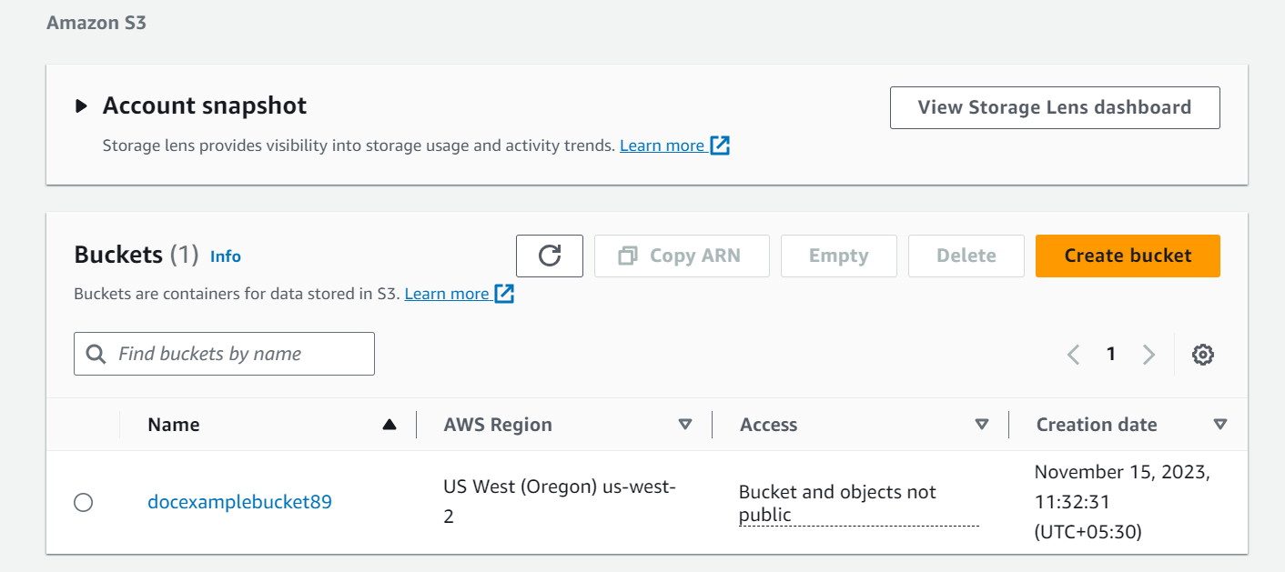

**Uploaded files to the bucket:**

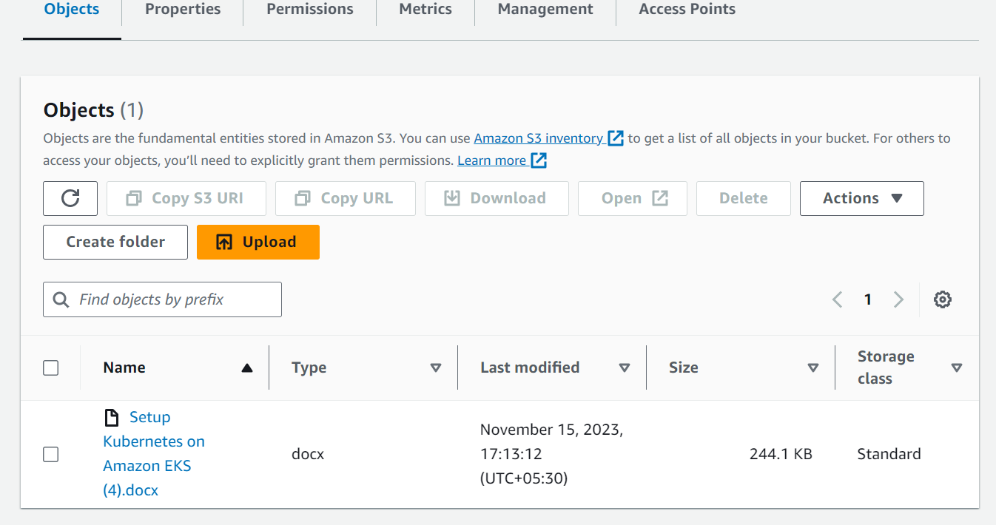

**Lauching 2 EC2 instance**

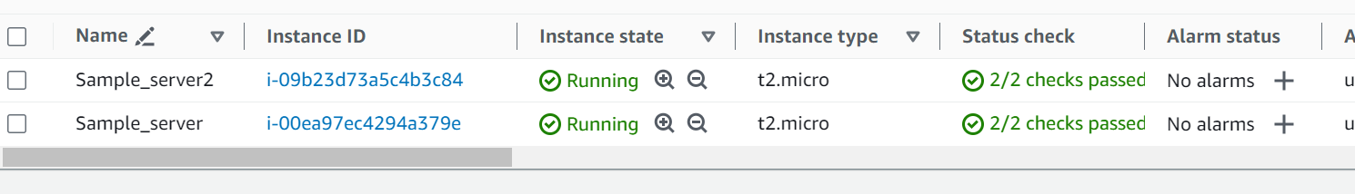

**Creating one application apache**

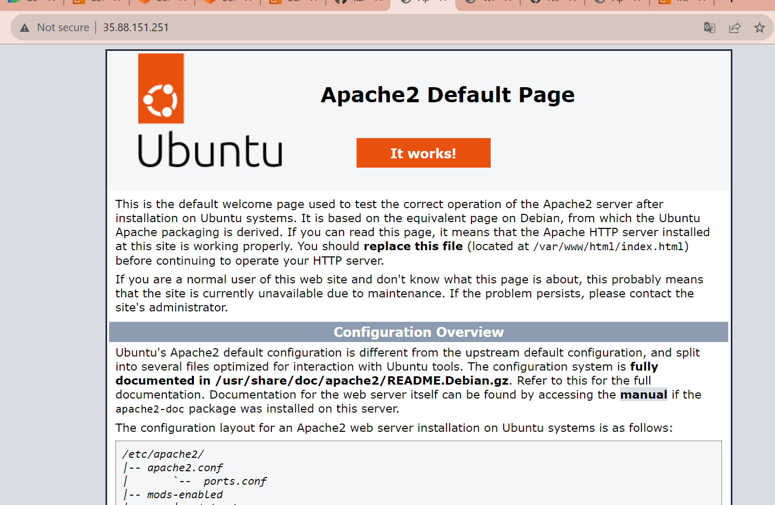

**Creating another application Nginx**

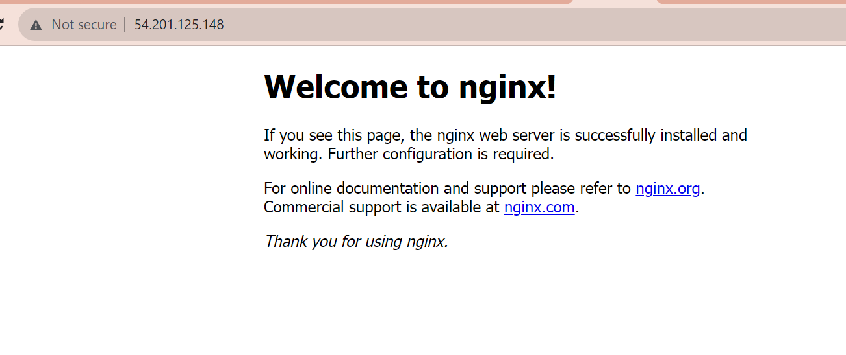

**Creating load balancer**

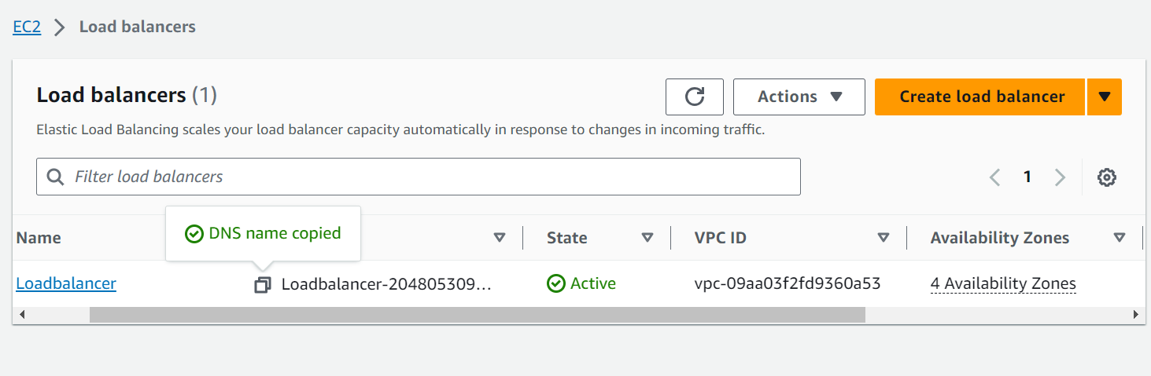

**Launching load balancer**

